

Real-Time Big Data Applications for Hadoop

­­­

|  |  |  |  |  |  |
| --- | --- | --- | --- | --- | --- |
| What Business Challenges are Solved? | |  |  |  |  |
| Powerful Solution |  | | Cost Effective Big Data Storage |  | Support for Low Latency Applications |
| MarkLogic in conjunction with HDP is a powerful solution for storing, accessing, reporting and analyzing massive amounts of information |  | | MarkLogic can leverage HDFS within a tiered storage model, seamlessly moving data to support specific SLAs and cost objectives |  | MarkLogic extends Hadoop so that real-time, low latency applications can also be supported such as real-time search and analytics |



Partner Brief

“Combining MarkLogic and HDP gives you the best of both worlds. Organizations benefit from low-cost distributed Hadoop storage while delivering ACID-compliant, real-time business applications.”

Jim Clark

Senior Director, Product Management  
MarkLogic

MarkLogic provides the only Enterprise NoSQL database platform that handles the volume, velocity, and variety of big data AND has built, tested, and deployed the enterprise features necessary to run at the heart of an organization.

MarkLogic is designed for today’s data, helping you find answers in documents, relationships, and metadata. Enjoy the flexibility of NoSQL to integrate data, and deploy in any environment—whether using Amazon Web Services, virtual machines, or on-premise hardware. MarkLogic is a hardened platform that is trusted to run mission-critical applications. It has uncompromised data resiliency with features like ACID compliance that ensure you will never lose data.

Combining MarkLogic Enterprise NoSQL with the Hortonworks Data Platform allows enterprises to augment Hadoop’s low-cost storage and batch analytics with real-time capabilities to create opportunities for new, immediate business insights.

www.hortonworks.com

MarkLogic in the Modern Data Architecture

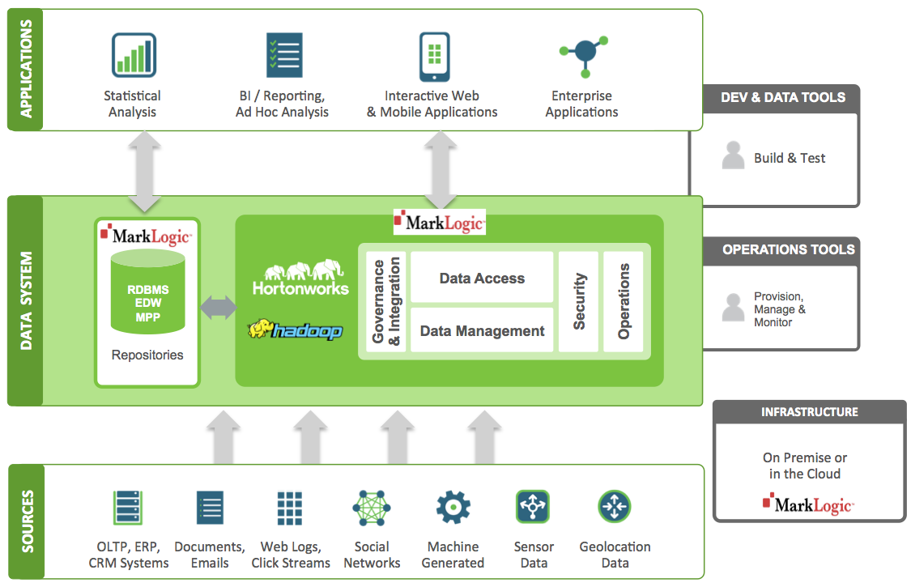 ­­

## MarkLogic is a Certified Technology Partner

## The Hortonworks Certified Technology Program reviews and certifies technologies for architectural best practices, validated against a comprehensive suite of integration test cases, benchmarked for scale under varied workloads and comprehensively documented.



## Features and Benefits of the Combined Solution

* MarkLogic enables real-time, low latency applications to run on HDP
* MarkLogic is built for heterogeneous structured and unstructured data and in conjunction with HDP, eliminates the need to map data to rows and columns for every type of analysis
* Users are able to store their data appropriately based on whether the data needs to be frequently accessed or can be stored for historical analysis

The MarkLogic Connector for Hadoop enables mixed analytical and operational workloads on HDP

Hortonworks is a leading commercial vendor of Apache Hadoop, the open source platform for storing, managing and analyzing Big Data. Hortonworks Data Platform, our distribution of Apache Hadoop, provides an open and stable foundation for enterprises and   
a growing ecosystem to build and deploy Big   
Data solutions.

Hortonworks is the trusted source for information on Hadoop, and together with the Apache community, Hortonworks is making Hadoop an enterprise   
data platform. Hortonworks provides unmatched technical support, training and certification programs for enterprises, systems integrators and   
technology vendors.

### Hortonworks. We do Hadoop.

For additional questions, contact:

* MarkLogic  
  [www.marklogic.com](http://www.partnerURL.com/hadoop)  
  (877) 992-8885
* Hortonworks  
  [www.hortonworks.com](http://www.hortonworks.com)  
  (855) 8-HORTON