

Business Excellence in

Big Data Analytics

­­­

|  |  |  |  |  |  |  |  |  |  |
| --- | --- | --- | --- | --- | --- | --- | --- | --- | --- |
| Business Challenges Solved | | |  |  | |  | |  | |
| Elimination of information overload |  | Mapping to the information value chain | | |  | | Complement existing teams with Big Data expertise | |
| Compegence provides workshops, consulting services and guidance to help enterprises navigate through the complexities of understanding Big Data solutions and architectures. |  | Compegence complements an enterprise in their “competing with analytics” journey with plans and methodology around Big Data adoption and deployment. | | |  | | Compegence helps enterprises by formulating analytical and big data opportunities, building the DW/BI/Analytics/Big Data practice and identifying reference architecture solution components. | |



Systems Integrator Brief

Compegence helps optimize the business decision life cycle by providing the Compegence Information Excellence Framework: a unified process, data and domain driven approach. Through this framework, Compegence helps enterprises manage the complexities of big data solutions so that they can realize their business goals and opportunities.

Compegence helps enterprises to:

* Achieve business excellence with process, data and domain driven information architecture maturity
* Speed up cycles of business monitoring and decision making
* Provide an optimized, best-in-class integrated hosted service
* Start competing with Information Excellence and insights

www.hortonworks.com

Compegence and Big Data Expertise

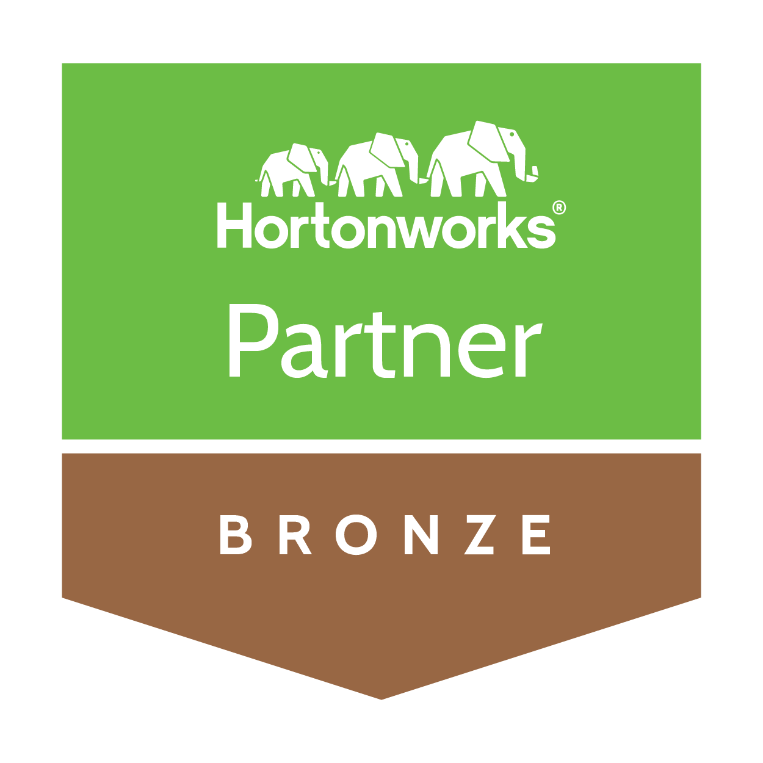 ­­

## Compegence is a Hortonworks Bronze System Integrator Partner

From cost savings scenarios to business process optimization and new revenue generating use cases,   
Hortonworks systems integrators and consultants play a crucial role in facilitating the discovery,   
solution development and the on-going operations of Hortonworks Data Platform implementations.

## Consulting Services

* Compegence provides consultative mentoring to groom and grow your team

## Methodology

* Compegence provides the Information Excellence Framework that provides a unified process to help Big Data adoption and deployment for the data warehouse and formulate, develop and deploy Big Data analytical solutions.

## Technical Focus

* Compegence complements an enterprise’s existing team with specialized Big Data expertise.

## Jump Start Capabilities

* Compegence identifies “competing with analytics” opportunities, helps to map dimensions of business performance for your business
* Compegence provides data and information life cycle audit and benchmarking

## Workshops

* Compegence offers a series of customized workshops about Big Data, Hadoop and analytics that help to enhance the enterprise IT team’s knowledge base

Hortonworks is a leading commercial vendor of Apache Hadoop, the open source platform for storing, managing and analyzing Big Data. Hortonworks Data Platform, our distribution of Apache Hadoop, provides an open and stable foundation for enterprises and   
a growing ecosystem to build and deploy Big   
Data solutions.

Hortonworks is the trusted source for information on Hadoop, and together with the Apache community, Hortonworks is making Hadoop an enterprise   
data platform. Hortonworks provides unmatched technical support, training and certification programs for enterprises, systems integrators and   
technology vendors.

### Hortonworks. We do Hadoop.

For additional questions, contact:

* Compegence  
  [www.co](http://www.co)mpegence.com
* Hortonworks  
  [www.hortonworks.com](http://www.hortonworks.com)  
  (855) 8-HORTON